

**XN PROJECT FINAL INDIVIDUAL PROPOSAL**

ALY6080 Integrated Experiential Learning

Fall 2019

Submitted on: Dec 12th, 2019

By:

ANUJ GOLESAR

**Instructor: Prof. Nathaneil Chu Hsein Lin**

|  |
| --- |
| Facebook Ads Targeting Analysis for - Viacom |
|  |

**MEMO**

**To:** Dr Moocarme

**From:** Anuj Golesar

**CC**: Dr Nathaneil Chu Hsein Lin

The following report summarizes the analysis which was performed on the CPM and page level demographic data provided by Viacom. This analysis involves the study of importance of demographics in CPM estimation. Moreover, it includes the study of conversion of impressions to engagement and its conversion rate across various age groups and gender based on advertisement conversion funnel. We can see the relation between different demographics and how it is changing the CPM values. The aim of this project is to help Viacom to save money by targeting right audience by analyzing especially age groups, account names for predicting CPM values. This report will help Viacom to know whether offering their price model to advertisers is worth or not based on the insights that we derived.

**APPROACHES:**

To understand the correlation between Demographics data and CPM estimates we used following approach.

1. Perform Exploratory Data Analysis on demographics page level data and find important features that are significant to estimation
2. Divide the CPM data in year 2018 and 2019 and train the model to predict the CPM values to see the anomalies or variation if any made by Facebook in their pricing model offered to Viacom.
3. Check for the Viacom accounts which are significantly contributing to higher conversion rate of impressions to CTA and help attain higher CPM values.

**RECOMMANDATIONS & DELIVERABLES:**

1. Viacom should consider following plot to strategies the creation of their custom content to be displayed on various websites.

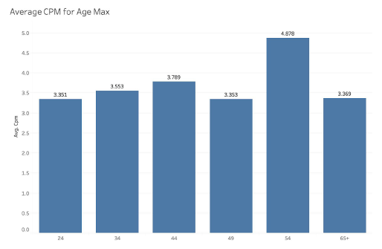

From the plot to the right, we see that age group between 45-54 are converting the impressions into CTA and thus contributing to higher CPM values. The reason behind the younger groups are not engaging could be the irrelevance of the content which is being displayed on sites.

1. Targeting younger age groups which can earn Viacom more profitable actions such as buying product online or watching add videos.

From the above plot we see that younger age groups are not amongst the ones which are bringing more CTAs. Offering good content to the young audience in which they are interested could increase the above CPM estimates for younger groups. For example, If a add is posted on Facebook targeting age group 13-17, offering them free episodes on watching lets say 3 adds would let them watch the episodes without having them to buy whole subscription would help Viacom.

1. After we train the CPM prediction model using 2018 and 2019 data with and without including the organic value as Independent variable. We found that organic reach or organic value is causing increase in the accuracy of the prediction models of CPM which means organic reach is helping Viacom in targeting particular demographic which is deemed to be important for the advertisers. It is recommended to Viacom to add more adds which can be seen by audience via organic search.
2. We have performed the clustering to find out combination of hIDs , age groups and gender which have similar attributes and effect on conversion rate.

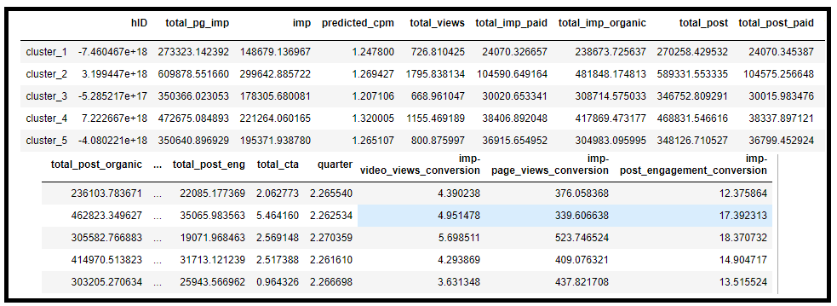

We can see that each cluster has own set of properties. We found out that not all clusters have good conversion rate. Viacom must focus on hIDs which are favorable for conversion and produces higher conversion rate and should invest more in those hIDs

1. Viacom must be prepared for the occasions such as Thanksgiving or Black Friday or any public holiday since on such occasions more audience tend to visit website for online purchase or they are sitting back in their home and may watch their favorite content . Such occasions can be cash in into more CTAs . From the following plot

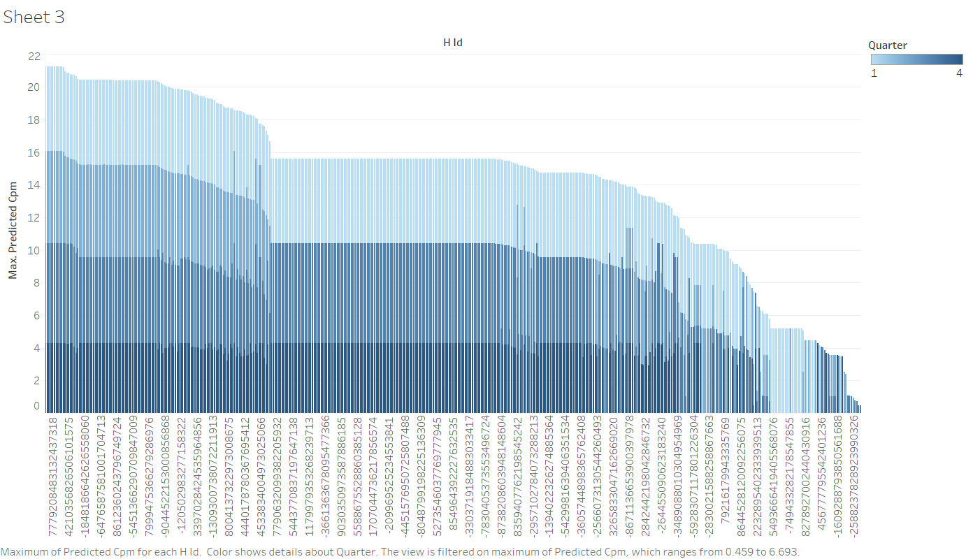

From the plot on left , we see that not always all the hIDs are contributing to higer CPM rates and conversion of impression to CTA. Thus find out those hIDs which are profitable such as MTV ,CMT , Paramount , PLUTOtv

For example, the GAMESPOT.COM is website which had almost 10 times more visitors on black Friday as compared to normal days in rest of the year . Thus such hIDs can be targeted to earn CTAs

**PROPOSED BUSINESS MODEL:**

To achieve more conversion rate based on analysis done in clustering I propose following business model for Viacom.

Lets say a advertiser needs 750 CTAs from the demographics that they claimed to be important for them.

$ y- CPM value

To calculate no of impression required to achieve 750 CTAs I propose following formula ,

X = A * 750 /B

Where , A no of CTAs and B no of page impression , thus for cost for 750 CTA will be

$ y *X / 1000 .

Now , We have

$ y – CPM investment

H – no of hIDs

$ X- total CPM invested by Viacom

Y -Suggested CPM for Viacom

Thus , if have $ X =$y*H

And Y = $y* h … where ( h < H )

Then we get $ x -Y = change in investment .

So , If Viacom chose or target specific hIDs which are responsible for greater conversion rate . Using above formulation great amounts of profit can be achieved.

**METHODS USED FOR ANAYSIS:**

For CPM value prediction and its imputation on unique gender page level data and organic data I used Random Forest Regressor model. And achieved the accuracy of about 80 % and 83 % for 2018 and 2019 data respectively. For funnel clustering I used K-means clustering in Python.

**CONCLUSION**

* Viacom should focus on targeting younger age group (17-45) by creating more customized content which is in interest of this age group.
* Viacom should be focusing on particular hIDs and demographics which shows higher conversion rate from the clustering analysis .
* The age groups which are visiting those hIDs try to recognize their penchant by collecting personal data such as which shows are watched frequently and during what time of the year, time of the day etc.
* Making use of information such as country from where the impression is generated
* Viacom should not waste their sources on paid promotions without determining the target audience and hIDs

**REFERENCES:**

[1]<https://www.viacbs.com/?gclid=CjwKCAiA58fvBRAzEiwAQW-hzWNE0Iyyq4Q1zwvGcSrExG9_i5l4CuN-pxzlehgJQ5JiQQ39YicmxxoCMlIQAvD_BwE>

##### [2] Hub Metrics Explained

Jan Griffiths - <https://help.uberflip.com/hc/en-us/articles/360020246972-Hub-Metrics-Explained>

##### [3] About Optin Cat Conversion and Impression Tracking (and How To Disable It)

<https://fatcatapps.com/knowledge-base/conversions-impressions/>